**Process Documentation**

Combining the datasets into one file involved first merging the information for the schools that was initially separated into elementary, middle, and high school, into one file with the combined dataset. All of the datasets came as a CSV file, which I then saved as an excel spreadsheet. Combining the school datasets involved simply copying and pasting each dataset onto a new excel spreadsheet since each of the three datasets had the same columns. I opened a new excel spreadsheet to use as the merged file and called it Merged Howard County Schools & Columbia Association Pools Datasets.

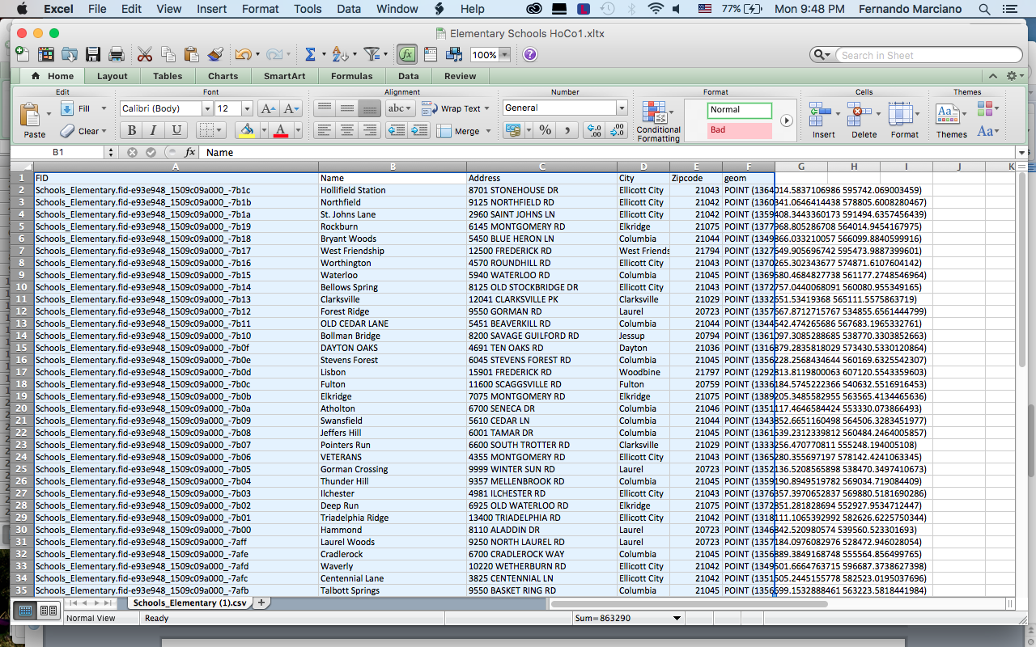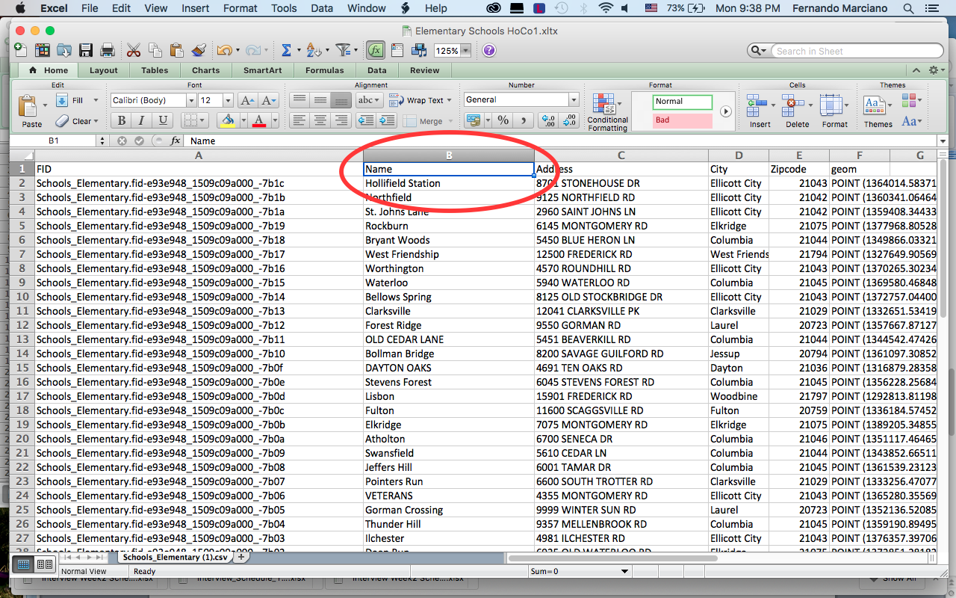Beginning with the dataset for elementary schools I clicked on cell B1 labeled Name and pressed Command A to select all of the data on the Mac (Ctrl A for PC). After select all, I pressed Command C (Ctrl C) to copy. Over to the newly created excel file I mouse clicked on the A1 cell and typed in using bold letters, Howard County Elementary Schools. I then clicked on cellblock A2 (pressing enter/return should do the same thing) to select it and pressed Command V (Ctrl V) to paste the copied elementary school dataset. All of the information filled into each cell nicely and with a few width adjustments for a few of the columns, like name and address, all of the information was displayed properly.

The next step was simply to repeat the steps of copying the school file, this time middle school, and paste it under the elementary school dataset. After copying the middle school dataset I went back over to the new excel spreadsheet, moved down one row from the last elementary school dataset row and again using bold letters typed in Howard County Middle School. Underneath, still in the A column I clicked the cell under the title I just wrote and pressed Command V to paste the middle school dataset. Once the dataset was pasted in place I deleted the first column with the column titles since it is the same as the ones at the top from the elementary school dataset.

Figure 2: Once you have selected the entire dataset the excel sheet should look like this.

Figure 1: Click on cell B1 and press Command A to select all followed by Command C to copy the entire dataset.

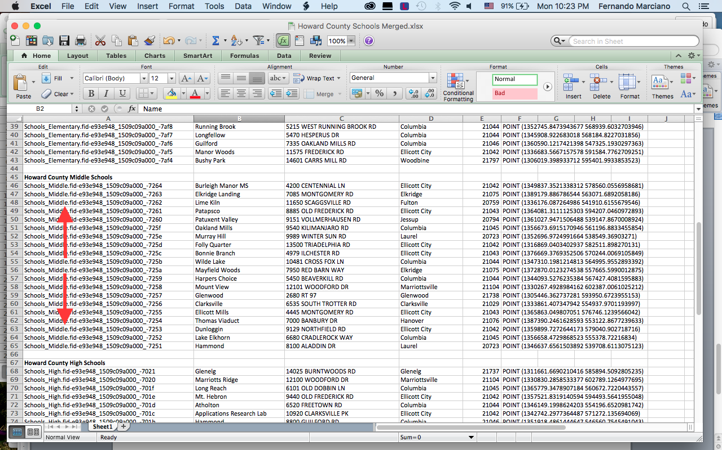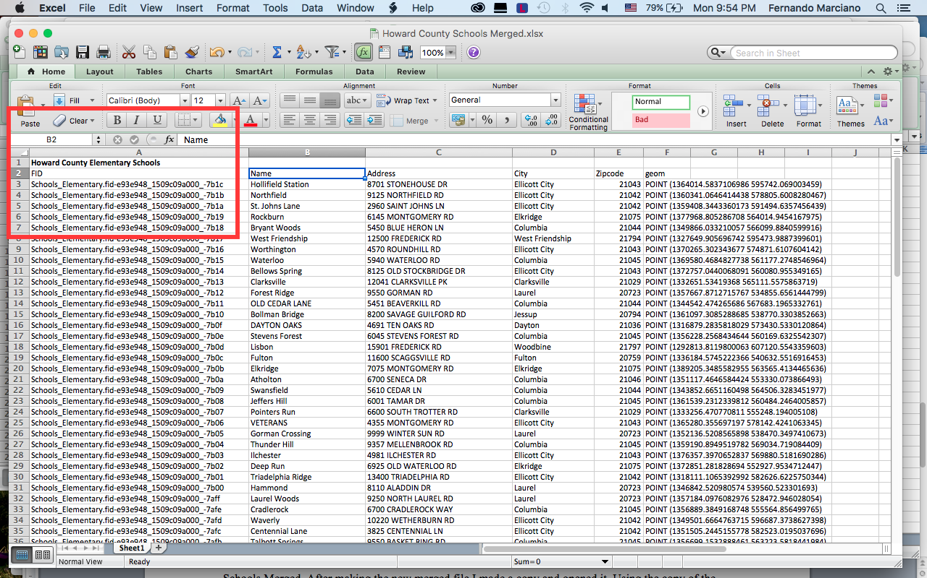 As was done for the middle school dataset, I simply repeated the process for the high school dataset and place it underneath the middle school dataset in the new merged file. Once all of the information was placed into one excel sheet I saved it. After making a copy of the new merged file I opened it. Using the copy of the excel spreadsheet (just in case I messed up somehow I have a backup) I proceeded to add the dataset with the CA pools information.

Figure 4: To avoid accidently scrolling into another grade block during a search in the entire merged dataset I left an entire row blank at the end of each grade block dataset.

Figure 3: To keep track of the different schools grade blocks I placed a title before the dataset in bold letters.

Fortunately, the CA pools dataset is set up very much in the same way as the datasets for the schools. The columns are all the same. It is almost like as if they were waiting to come together. With the columns being the same, I repeated the process one more time by copying and pasting the CA pools dataset to the merged excel spreadsheet. I pressed Command C for copy all so again I had to delete the row with the column titles.

**Note:** It is important to remember that although the dataset for CA pools only contain pools inside CA boundaries, the school datasets are for the entire Howard County. When looking at the data, only those pertaining to CA will be of focus for this project.

* Marciano, F. S. (2015). Merged Howard County Schools & Columbia Association Pools Datasets. [Data file].

**Word Count: 578.**